Video 13 :- Deamon Threads

# What is Deamon Thread ?
A Thread which are executing in the background is called deamon thread.
ex. Garbage collector, Attatch Listener, Single Dispatcher etc.

# What is the advantage or purpose of Deamon Thread ?
Purpose :- The main objective of deamon thread is to provide support for non deamon threads ( main thread ).
ex. If main thread runs on the low memory then jvm run GC to destroy useless objects, So that number of bytes of free memory will be improved with this free memory main thread can continue its execution.
Usually Deamon thread having low priority but based on our requirement, deamon threads can run with high priority also.
( Main thread low space --> jvm ( will make GC to thread priority to 10 then it will remove unused object , gain space--- set priority to 1) --> main thread continue)

We can check the deamon nature of a thread by using isDeamon() method of thread class. [ public boolean isDeamon() ]
We can change a deamon nature of thread by using setDeamon () method.
[ public void setDeamon(boolean b) ]

But changing deamon nature is possible before starting of a thread only. After starting thread if we are trying to change the deamon nature then we will get runtime exception saying .. IllegalThreadStateException.

# What is the Default nature of the thread.
By default main thread is always non-deamon and for all the remaining threads deamon nature will be inheritated from parent to child i.e if the parent thread is deamon then automatically child thread is deamon and If the parent thread is non-deamon then automatically child thread is non-deamon.

Note :- It is impossible to change the deamon nature of the main thread beacuse it is already started by jvm at beagining.

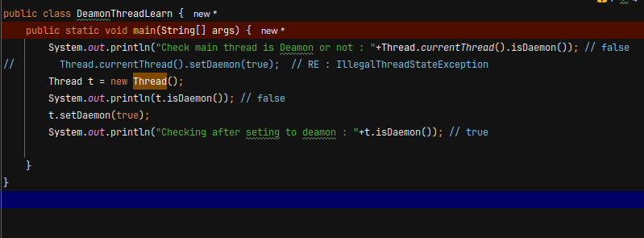

Whenever last non-deamon thread terminates automatically all deamon threads will be terminated irrespective of their position.

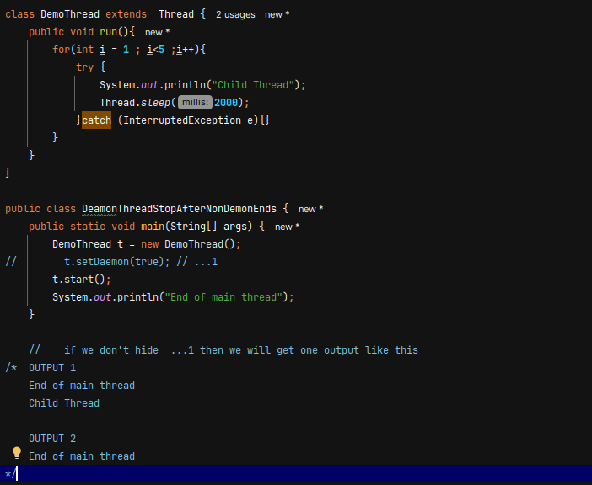

If we are commenting line 1 then both child and main threads are non-deamon and Hence both the threads will be execution.
If we are not commenting line 1 then main thread is non-deamon and the child thread is deamon hence whenever main thread terminates automatically child thread will be terminated, In this case output is [ Output 1 , Output 2 ]
Output 3
Child Thread
End of main Thread

Video 14 :- FAQ

Java multithreading concept is implemented by using the following two models
- Green Thread model
- Native OS Model

# Green Thread Model :-
The Thread which is managed completely by jvm without taking underlying OS support is called Green Thread.
Very few operating system like ‘Sun Subries’ provide support for green thread model.
Anyway green thread model is depricated and not recommended to use.

#Native OS model :
The Thread which is managed by the jvm with the help of underlying OS, is called Native OS model.
All windows based OS provide support for Native OS model

# How to stop a thread?
We can stop a thread execution by using stop method of thread class.
public void stop()
If we called stop method then immediately that thread enter into the dead state , Anyway stop is deprecated and not recommeded to use.

Resource Leakage: If a thread opens resources, such as a database connection, and the stop method is called before it can close them, those resources will remain open and wasted

# How to suspend and resume of a Thread?
we can suspend a Thread by using suspend of Thread a class then immediately that Thread entered into suspended thread. We can resume a suspended Thread by using resume method from Thread class then suspended Thread can continue its execution.

- public void suspend()
- public void resume()

Anyway this methods are deprecated and not recommended to use.

#Why suspend() and resume() Are Deprecated
They were deprecated because they can easily lead to deadlocks and application freezes.

- Deadlock Risk (Primary Reason)
When a thread is suspended, it does NOT release the locks it holds.
If another thread needs those locks, it will wait forever.

- Inconsistent Program State
Threads can be suspended at any point, even in the middle of:
- Updating shared data
- Executing critical sections
- This can leave shared objects in a partially updated or corrupted state.

Resume Can Be Missed
If resume() is called before suspend(), the resume signal is lost.
The thread may remain suspended forever.
This behavior is non-deterministic and unsafe.

# Full life cycle of Thread
